

**Project Report on**

**Blood Bank**

**B.C.A. SEM - 5**

**Academic Year 2018-19**

**Developed By:**

**ANKIT K KANZARIYA.**

**Index**

|  |  |  |
| --- | --- | --- |
| NO | NAME | PAGE NO |
| 1. | Acknowledgement | 3 |
| 2. | Preface | 4 |
| 3. | Project Profile | 6 |
| 4. | Introduction   * Basic Introduction Project * Objective and Scope * Tools and Technologies used | 6 |
| 5. | System Analysis   * Preliminary analysis &Information gtherning * Feasibility Study * System Requirement Specification | 8 |
| 6. | System Design   * Data Flow Diagram * E-R Diagram * Data Base Design with Normalization * Screen Shorts | 15 |
| 7. | System Testing | 25 |
| 8. | Implementation & Maintenance | 31 |
| 9. | Bibliography | 32 |

**Acknowledgement**

The present of this report gives us the feeling of the final frontier toward achieving the B.C.A degree. The activity of going through industrials orientation has bridged the gap between the academics and practical real life work of us.

It has prepared us to apply ourselves to becomes good it professional Naturally, it requires lots of people support to complete this project.

In acknowledge, Hear first of all we would like to thanks our college SmtJ.J.Kudalila commerce college they such a big opportunity for develop a project. We express our sincere thanks and gratitude to MrJitu sir, lecturer of computer science department for their guidance.

We would Like the all those people who help as to make this project directly or indirectly.

**PREFACE**

Theory of any subject is important but without its practice it becomes useless particularly for the computer student. A computer student can’t become a perfect man of technologist without practical understanding of brach.

We can also say, ”Experience is the best teacher” so our project is one kind of experience, the part of our life. Through the project we have learnt good, real and practical application.

The project training in the B.C.A. course gives us the exposure to real world. The aim of the project training by understanding a project is to have practical experience of the real world.

**Definition of project**

Using this people can purchase blood online. And in this project buyer can buy blood and donor can donate the blood online. And administrators can so all the information about buyer and donor.

* In our project, several facilities of blood bank are including like a blood info, Availability of blood inquiry, News, camp etc.
* Admin can enter details of blood provider organization and also Hospital details.
* Visitor/patient can see the information of blood, camp& inquiry.
* Any visitor can see also search for blood inquiry to experts also give feedback of current system, contact detail etc.
* Only admin can add new user that use this software candid any setting in this software.
* Main purpose of this project is to provide best service and best.
* **Project profile**

|  |  |
| --- | --- |
| **Project Name** | Blood Bank Management system |
| **Front End** | C sharp |
| **Back End** | Mysql |
| **Documentation tool** | Microsoft word 2007 |
| **Operating system** | Windows 10 |
| **Web Browser** | Google chrome |
| **Guided By** | Mr. Jitu sir |
| **Submit to** | Smt j.j.kundaliacommerce college |

**System Requirement**

During this phase of SDLC, one has to en list the configuration of hardware and support software essential to execute the specified application.

|  |  |  |  |  |  |  |  |  |  |  |  |  |  |  |  |  |  |  |
| --- | --- | --- | --- | --- | --- | --- | --- | --- | --- | --- | --- | --- | --- | --- | --- | --- | --- | --- |
| **Minimum Hardware Requirement**   |  |  |  | | --- | --- | --- | | **Category** | **Client side** | **Server side** | | Processor | Intel Dual core or Higher | Intel core 13 or higher | | Hard Disk Drive | 10MB or Higher | 500MB or Higher | | RAM | 256MB or Higher | 2 GB | | Monitor | 18” Wide color | 18” Wide color | | Network Devices | Network Adapter | Network Adapter | |

|  |  |  |  |  |  |  |
| --- | --- | --- | --- | --- | --- | --- |
| **Client side Software Requirement**   |  |  | | --- | --- | | Software | Remark | | Windows 10 or Higher | Used to run web browser | | Web Browser | Used to display website |   **Internet connection must be required** |

**System Analysis**

* **Preliminary & Information Gathering Preliminary**

As for as our project is concern, We had studied various websites related to online matrimonial**.**

* **Designing**

As far as our project is concerned we have designed project using rough designing on our project workbook. To make efficient development model we have developed various diagram data flow diagram, context diagram to understand the user interactions, flow of data though the information system respectively.

* **Testing**

It is to used establish the presence of defects in program and it is used to help judge whether or not the program is useable in practice. Thus project testing is use for validation and verification, which ensure that website confirms to its specifications and meets the need of the tests have been succeeded. Testing has been applied for all the stages of process.

* **Implementation**

After a complete a testing phase of SDLC we provide final implement to our project.

* **Gantt chart**

A Gantt chart is a type of bar chart, developed by Henry Gantt Which illustrates a project schedule .Gantt charts illustrate the start and finish dates of the terminal element and summary element of a project Terminal element And summary element comprise the work breakdown structure of the project.

some Gantt charts also show the dependency relationships between activities. Gantt charts can be used to show current schedule using percent-complete shadings. Gantt chart is also known as a timeline chart.

|  |  |  |  |
| --- | --- | --- | --- |
|  | **July** | **August** | **September** |
| **Analysis** | (10 Days) | | |
| **Feasibility** | (7 Days) | | |
| **Design** | (13 Days) | | |
| **Coding** | (56 Days) | | |
| **Testing** | (3 Days) | | |
| **Implementation** | (4 Days) | | |

* **PERT CHART**

A pert chart is a project management tool used to schedule, organize and coordinate tasks within a project. It stand for program Evaluation Review Technique. Methodology developed by the U.S. Navy in the 1950s to manage the Polaris submarine Missile program. A similar methodology, the Critical Part Method (CPM) was develop for project management.

**Flow Chart**

At the Beginning of you process improvement efforts, an as is Flowchart helps you team and other involved in the process to understand how it currently works. The team may find it helpful to compare this as at is Flowchart with a diagram of the way the process is supposed to work. Later, the team will develop a Flowchart of point, your team may want to create an ideal Flowchart to show how you would ultimately like the process to be performed. Among the benefits of using Flowchart are that they.

Promote understanding of a process by explaining the steps pictorially. People may have differing ideas about how a process works. A Flowchart can help you gain agreement about the sequence of steps. Flowcharts promote understanding in a way that written procedures cannot do. One good Flowchart can replace pages of words.

Identify problem areas and opportunities for process improvement Once you Break down the process steps and diagram them, problem area become more visible. It is easy to spot opportunities for simplifying and refining your process by analyzing decision points, redundant steps, and rework loops.

**Front end Tools**

**Visual studio:**

Microsoft visual studio is an integrated development environment from Microsoft.

It can be used to develop console and graphical user interface application along with windows Forms applications, web application and Web services in both native code together with managed code for all platform support by Microsoft windows, windows phone windows CE, .Net Framework .Net compact framework and Microsoft silver light.

The .Net Framework is a software framework that runs primarily on Microsoft Windows, It include a large library and supports several programming languages which allow language interoperability The .Net Library is available to all the programming languages that .Net supports. Programs written for the .Net framework execute in a software that.Net Framework execute in a software environment, Known as the Common Language Runtime, an application virtual machine that provides important services such as security, memory management, and exception handling . The class library and the CLR together constitute the .Net framework.

**Back end Tools**

**MYSQL:**

MYSQL, the most popular open source SQL database management system is developed, distributed, and support by MYSQL AB is a commercial company, founder by the MYSQL, developers; it is a second generation open source company that unites open source values and methodology with a successful business model. Many Developers in the world select MYSQL and PHP for developing their website.

In list to a picture gallery or the vast amounts of information in a corporate network a database is a structured collection of data. It may be anything from a simple shop. To add, access and process data store in a computer database, you need database management system such as MYSQL server.

**Feasibility study**

Feasibility studies aimed to objectively and rationally uncover the strengths and weaknesses of an existing business or proposed venture, opportunities and threats present in the environment, the resources required to carry through and ultimately the prospects for success. In its simplest terms, the two criteria to judge feasibility are cost required and values to be attained.

* **Technical feasibility :**

In blood bank project all management it is Accuracy available.

* **Economic feasibility :**

The purpose of blood bank project is economic feasibility study is to demonstrate the net benefit of a proposed project for accepting or disbursing electronic user/benefits taking into consideration the benefits and costs to the agency, and the general public as a whole.

* **Operational feasibility**

In operational feasibility are support to the user and donors. It works properly and provide the all information.

**Data Dictionary**

* **Login**

|  |  |  |  |  |
| --- | --- | --- | --- | --- |
| **No** | **Field** | **Data type** | **Size** | **Constraint** |
| 1 | Username | Varchar | 15 | Not null |
| 2 | Password | Varchar | 15 | Not null |

* **Register**

|  |  |  |  |  |
| --- | --- | --- | --- | --- |
| **NO** | **Field** | **Data type** | **size** | **constrain** |
| 1 | Doner_id | Int | 11 | Not null |
| 2 | Name | Varchar | 50 | Not null |
| 3 | Age | Int | 3 | Not null |
| 4 | Address | Varchar | 100 | Not null |
| 5 | Gender | Varchar | 6 | Not null |
| 6 | DOB | Data | Null | Not null |
| 7 | Weight | Int | 3 | Not null |
| 8 | States | Varchar | 15 | Not null |
| 9 | City | Varchar | 20 | Not null |
| 10 | Mobile no | Int | 10 | Not null |
| 11 | Phone no | Int | 10 | Not null |
| 12 | Email_id | Varchar | 50 | Not null |
| 13 | Blood type | Varchar | 4 | Not null |
| 14 | Data | Data | Null | Not null |

* **Blood purchase details**

|  |  |  |  |  |
| --- | --- | --- | --- | --- |
| **No** | **Data type** | **Field** | **Size** | **constraint** |
| 1 | Varchar | Blood_type | 5 | Not null |
| 2 | Int | No_of_units | 15 | Not null |
| 3 | Varchar | Blood_bank | 50 | Not null |
| 4 | Int | Price_per_units | 20 | Not null |
| 5 | Int | Total_price | 20 | Not null |
| 6 | date | Purchase_date | Null | Not null |

* **States**

|  |  |  |  |  |
| --- | --- | --- | --- | --- |
| **NO** | **Field** | **Data type** | **size** | **constrain** |
| 1 | state_id | Int | 50 | Not null |
| 2 | State_name | Varchar | 50 | Not null |
| 3 | Country_id | Int | 11 | Not null |

* **Blood type & price**

|  |  |  |  |  |
| --- | --- | --- | --- | --- |
| **NO** | **Field** | **Data type** | **size** | **constrain** |
| 1 | Blood type | Varchar | 5 | Not null |
| 2 | price | Int | 5 | Not null |

**Screen Shots**

**HOME**

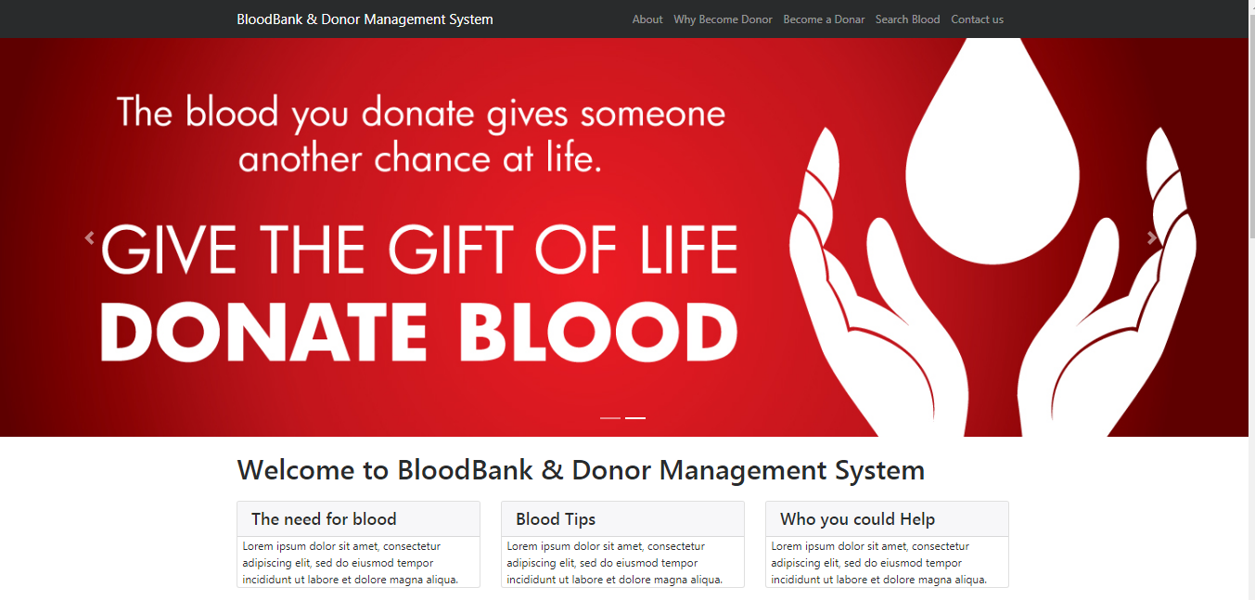

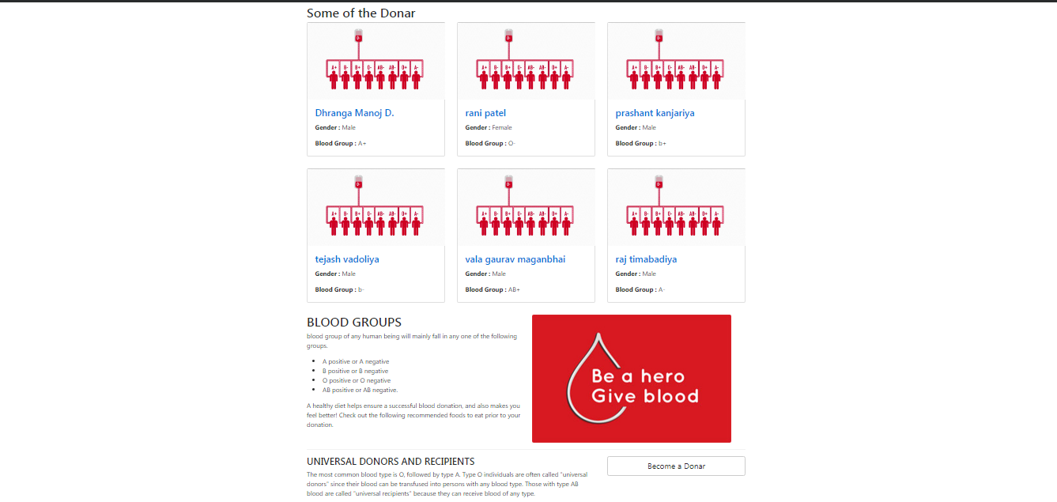

* Admin Login:-

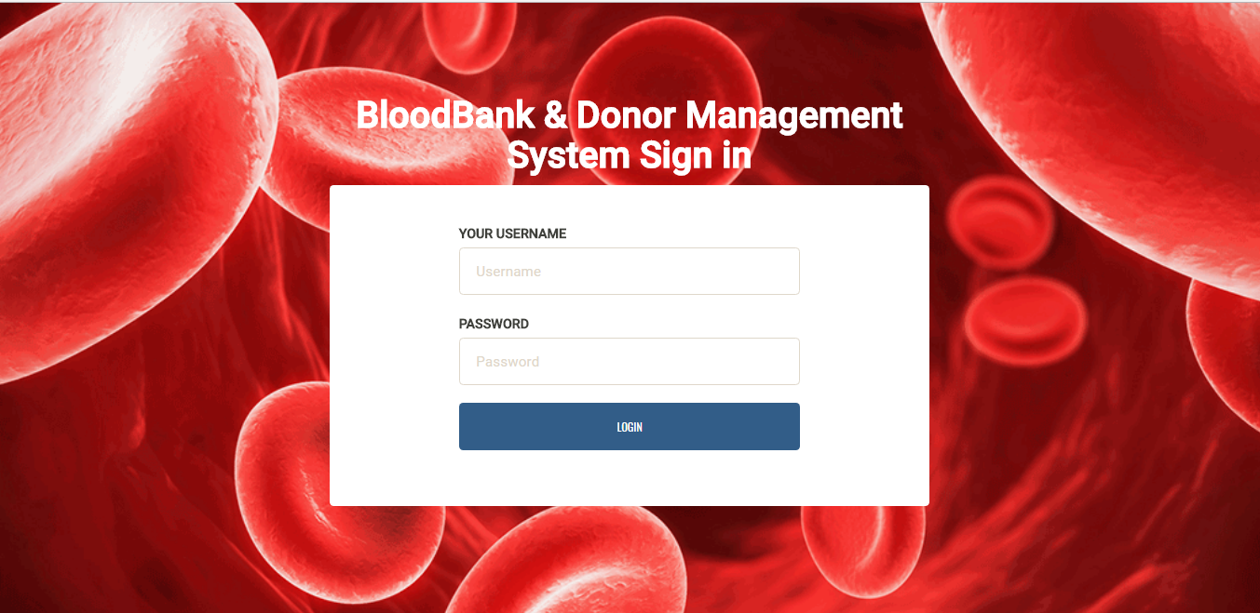

* Dashboard:-

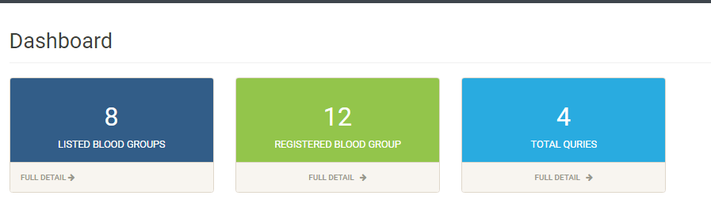

* Add Donor:-

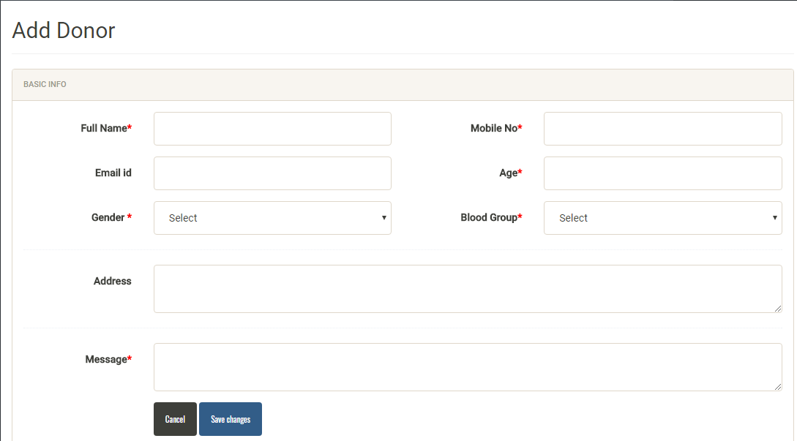

* Search Donor:-

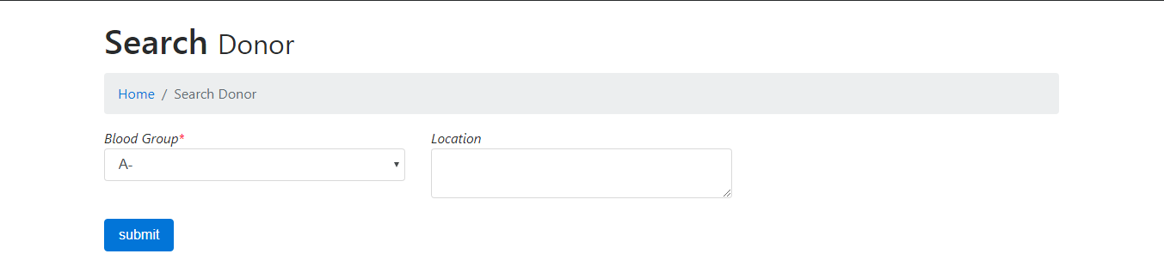

* Manage Blood Groups:-

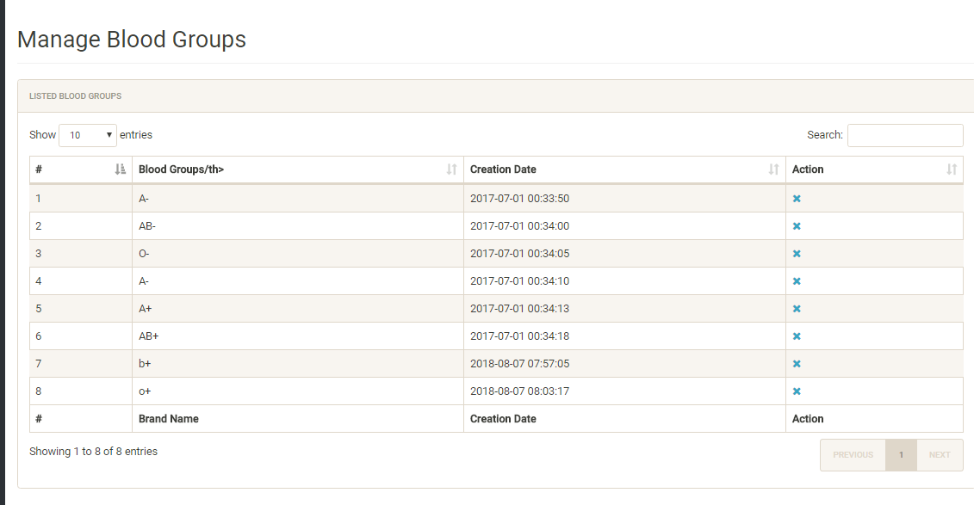

* Contact Us:-

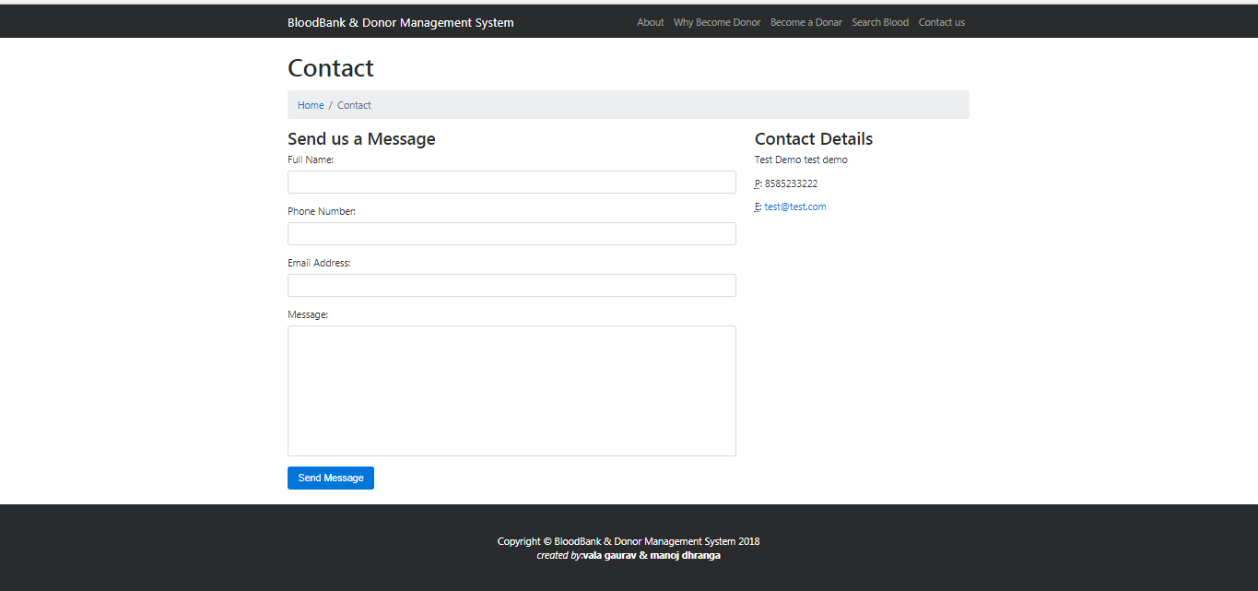

* About us:-

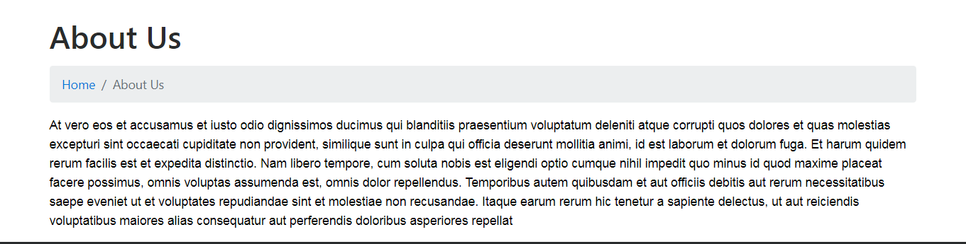

|  |  |  |
| --- | --- | --- |
| 0 | 10 | 10 |
| Implementation | | |
| 0 | 0 | 10 |

|  |  |  |
| --- | --- | --- |
| 0 | 10 | 10 |
| Coding | | |
| 0 | 0 | 10 |

|  |  |  |
| --- | --- | --- |
| 10 | 07 | 10 |
| System Analysis | | |
| 0 | 0 | 10 |

|  |  |  |
| --- | --- | --- |
| 0 | 10 | 10 |
| Feasibility Study | | |
| 0 | 0 | 10 |

|  |  |  |
| --- | --- | --- |
| 17 | 13 | 30 |
| System Design | | |
| 0 | 0 | 30 |

|  |  |  |
| --- | --- | --- |
| 83 | 03 | 86 |
| Testing | | |
| 83 | 0 | 86 |

|  |  |  |
| --- | --- | --- |
| Early  start | Duration | Early  Finish |
|  | | |
| Late  Start | Stack | Late  Finish |

Since there are no overloading activities in this case, the critical path is same as the path shown above. There is also zero stack time due to this relation.

F

Date

Email Id

Phone No.

Mobile no.

City

State

Weight

DOB

Gender

Address

Age

Name

Register

Start

**Stop**

**Decision**

**Home**

**Process**

Email/Password

**No**

**Yes**

**E-R Diagram**

Donate

Registration

Blood purchase

**Software Testing**

**Abstract:**

Software tesing is any activity aimed evaluating and attribute or capability of program system and determining that it meets its required result software quality and widely by programming and tester. Testing is more than just debugging the purpose of testing can be quality assurance, verification and validation or reliability estimation. Testing can be used an generic metrics as well.

**Static Testing:**

The verification activities fail into category of static testing. During static testing, you have a checklist to check whether the work you doing is going as per the set standard of the organization. These standards can be for coding, Integrating and deployment.

**Dynamic Testing:**

Dynamic Testing involves working with the software giving input values as checking if the output is as expected. These are the validation Activities unit Tests, Integration Tests, system Test and Acceptance Test are few of the Dynamic Testing Methodologies.

**Dynamic Testing:**

Unit Tesing is testing of individual hardware or softwar units or group of related units or related units. If admin username and incorrect so the home from dose not open permission And re-type valid username and password for login.

In the Register form user must be put up the given information then if the information is in correct user Re-type information or is valid information so userregistered.

In the donor is not gister the doner must be first register then after Doner was put up the Information for gives in form and Doner was Do this donate blood

The people who needs A Requirment of blood this people can purchase the blood.

**Integration Testing:**

Integration testing is testing in which software components , Hardware components ,or both are combined and tested to evaluate the interaction between them test cases are written which explicitly examine the interface between the various units. These test cases can be black box test requires program unites to Interfact. Alternatively, White-box test cases are written which explicitly exetcise the interfase that are Known to the tester.

# IMPLEMENTATION AND EVALUATION

During the software-testing phase each module of software is thoroughly tested for bugs and for accuracy of output. The system developed is very user-friendly and the detailed documentation is also given to the user as online help wherever necessary. The implementation phase normally ends with the formal test involving all the components.

The entire system was developed using the ASP, HTML, JavaScript, Personal Web Server, and Oracle 8 as back end. The HTML is used to design the web page. The Personal Web Server is used to understand the client’s request and to send response to them. The VBScript are used for client-side validations so that the user can enter only appropriate input in the input fields. The Oracle 8 is the back end tool where the database resides.

Hence the design of the entire system is user-friendly and simple the implementation has been quite easy.

LIMITATION OF THE PROJECT

* It is a not fully automated system.
* Very slow printing.
* User maintenance is not included.
* No Keyboard available shortcuts.
* **FUTURE ENHANCEMENT :-**
* In future, we are planning to put it online.
* Online help & support can be introduce into the system.
* Good GUI environment can be added into the system.
* Good database can be added in the system.
* More Security features can be added in the system.
* Extra new forms will be created for shopping related.
* **CONCLUSION :-**

We have created our project on “Online Watch Shopping” Which gives us idea about how the shopping world is working and also about the shopping order with computer. it also help the user to maintain all the tasks related to the form. it give me great please to inform you that we have gone through a very happy atmosphere with the special thanks to the director.

Bibliography

* **Reference :-**
* **Microsoft Word :-**
  + - * Used For Report Creation.
* **Website :-**
  + - * [www.google.com](http://www.google.com)
      * [www.wikipedia.com](http://www.wikipedia.com)
      * [www.w3schools.com](http://www.w3schools.com)

